1️⃣ ENTERPRISE HIGH-LEVEL ARCHITECTURE DIAGRAM

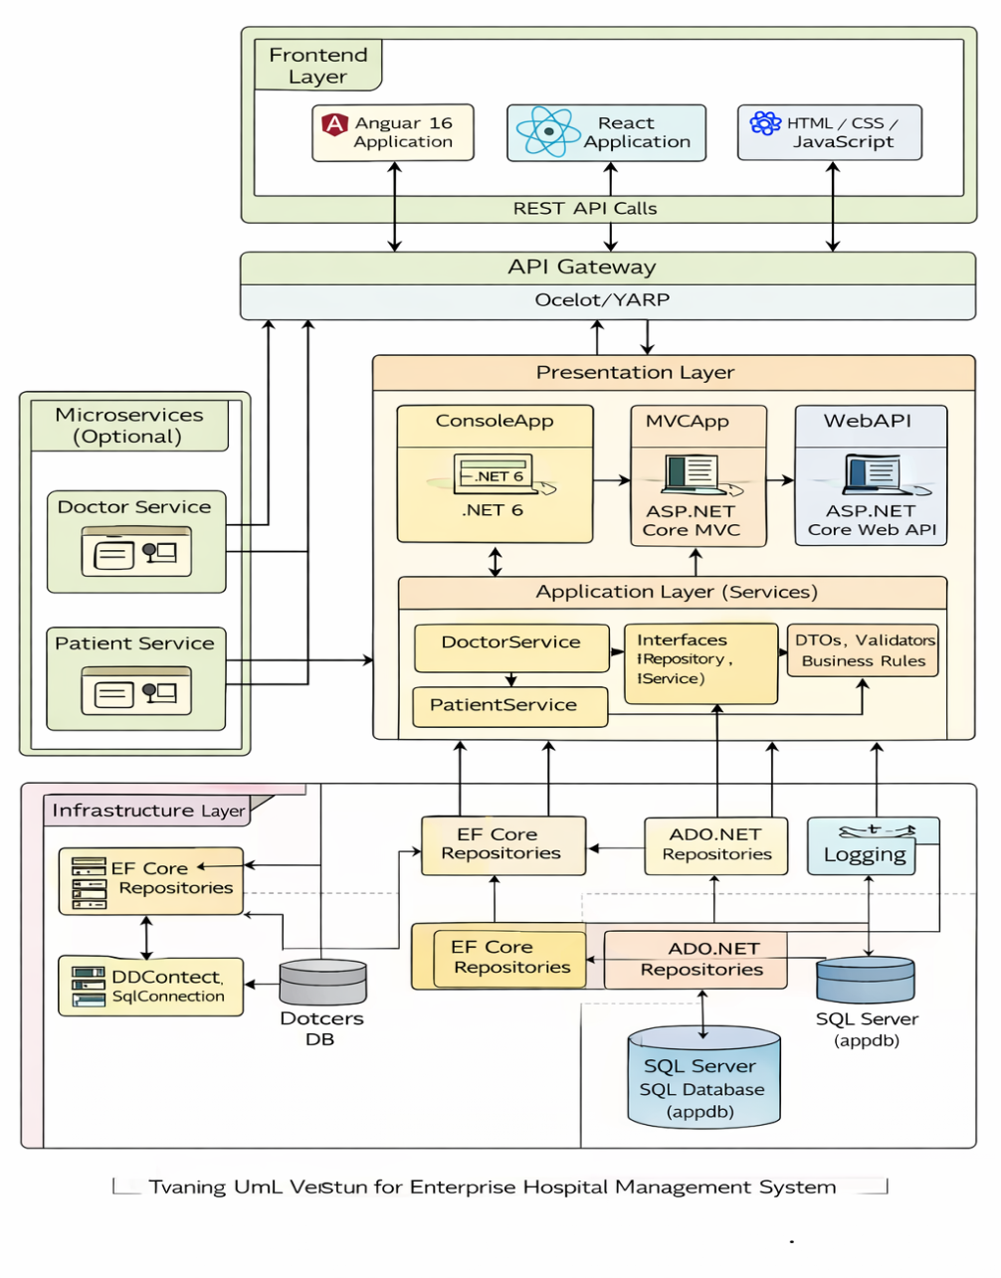

┌─────────────────────────────┐
│ FRONTEND LAYER │
│─────────────────────────────│
│ Angular 16 Application │
│ React Application │
│ HTML / CSS / JavaScript │
└──────────────┬──────────────┘
│ REST API Calls
▼
┌─────────────────────────────┐
│ API GATEWAY (Optional) │
└──────────────┬──────────────┘
▼
┌──────────────────────────────────────────────────┐
│ PRESENTATION LAYER │
│──────────────────────────────────────────────────│
│ Console Application (.NET 6) │
│ ASP.NET Core MVC │
│ ASP.NET Core Web API │
└──────────────┬──────────────────────────────────┘
▼
┌──────────────────────────────────────────────────┐
│ APPLICATION LAYER (Services) │
│──────────────────────────────────────────────────│
│ DoctorService │
│ PatientService │
│ DTOs │
│ Validators │
│ Business Rules │
└──────────────┬──────────────────────────────────┘
▼
┌──────────────────────────────────────────────────┐
│ CORE (DOMAIN LAYER) │
│──────────────────────────────────────────────────│
│ Entities (Doctor, Patient) │
│ Interfaces (IRepository, IService) │
│ Custom Exceptions │
└──────────────┬──────────────────────────────────┘
▼
┌──────────────────────────────────────────────────┐
│ INFRASTRUCTURE LAYER │
│──────────────────────────────────────────────────│
│ EF Core Repositories │
│ ADO.NET Repositories │
│ DbContext │
│ Logging (File Logger) │
└──────────────┬──────────────────────────────────┘
▼
┌──────────────────────────────────────────────────┐
│ DATABASE │
│──────────────────────────────────────────────────│
│ SQL Server (appdb) │
│ Doctors Table │
│ Patients Table │
└──────────────────────────────────────────────────┘

🏗 2️⃣ CLEAN ARCHITECTURE FLOW
UI Layer → Application Layer → Domain Layer
↓
Infrastructure Layer
↓
Database
👉 Domain does NOT depend on Infrastructure
👉 Infrastructure depends on Domain
👉 UI depends on Application
This follows Clean Architecture Principles

🏗 3️⃣ MICROSERVICES ARCHITECTURE DIAGRAM
When converting to Microservices:
┌────────────────────────┐
│ Angular / React │
└─────────────┬──────────┘
│
┌───────────────┐
│ API Gateway │
└──────┬────────┘
│
┌──────────────────────┴──────────────────────┐
▼ ▼
┌────────────────────┐ ┌────────────────────┐
│ Doctor Service │ │ Patient Service │
│--------------------│ │--------------------│
│ Controller │ │ Controller │
│ Application Layer │ │ Application Layer │
│ EF Core / ADO.NET │ │ EF Core / ADO.NET │
│ SQL Database │ │ SQL Database │
└────────────────────┘ └────────────────────┘
Optional:
- RabbitMQ for communication
- JWT Authentication
- API Gateway (Ocelot)

🏗 4️⃣ PROJECT STRUCTURE DIAGRAM (Visual Studio Solution)
HospitalManagementSolution
│
├── Core
│ ├── Entities
│ ├── Interfaces
│ ├── Exceptions
│
├── Application
│ ├── Services
│ ├── DTOs
│ ├── Validators
│
├── Infrastructure
│ ├── Data
│ │ ├── AppDbContext
│ │ ├── EF Repositories
│ │ ├── ADO Repositories
│ ├── Logging
│
├── ConsoleApp
├── MVCApp
├── WebAPI
├── DoctorMicroservice
├── PatientMicroservice
│
└── Frontend
├── angular16-app
├── react-app

🏗 5️⃣ DATA ACCESS STRATEGY DIAGRAM
Students implement BOTH:
Application Layer
│
┌──────────┴──────────┐
▼ ▼
EF Core Repository ADO.NET Repository
│ │
└──────────┬──────────┘
▼
SQL Server
Use Dependency Injection to switch between them.

🏗 6️⃣ EXCEPTION & LOGGING ARCHITECTURE
User Action
↓
Presentation Layer
↓
Application Layer
↓
Exception Thrown
↓
Global Exception Handler
↓
Logger Class
↓
errorlog.txt

🏗 7️⃣ DEPLOYMENT ARCHITECTURE DIAGRAM
Client Browser (Angular / React)
↓
IIS / Kestrel
↓
ASP.NET Core Web API
↓
Application + Infrastructure
↓
SQL Server
Microservices Deployment:
Docker Container 1 → DoctorService
Docker Container 2 → PatientService
Docker Container 3 → SQL Server
Docker Container 4 → API Gateway

🏗 8️⃣ TECHNOLOGY MAPPING DIAGRAM
Layer | Technology
Frontend | Angular 16 / React
API | ASP.NET Core Web API
MVC | ASP.NET Core MVC
Console | .NET 6 Console
Application | C#
ORM | EF Core
Direct DB | ADO.NET
DB | SQL Server
Logging | Custom File Logger
Exception | Custom Exceptions
Microservices | ASP.NET Core + Docker

🎯 FINAL ENTERPRISE VIEW
This architecture allows:
✔ Console Training
✔ MVC Training
✔ Web API Training
✔ Angular Integration
✔ React Integration
✔ Microservices Introduction
✔ ADO.NET + EF Comparison
✔ Clean Architecture Concepts
✔ Dependency Injection
✔ Exception Handling & Logging
✔ Real Enterprise Simulation

If

